Part 1 – Filling Tables with Data

1. First VidCast

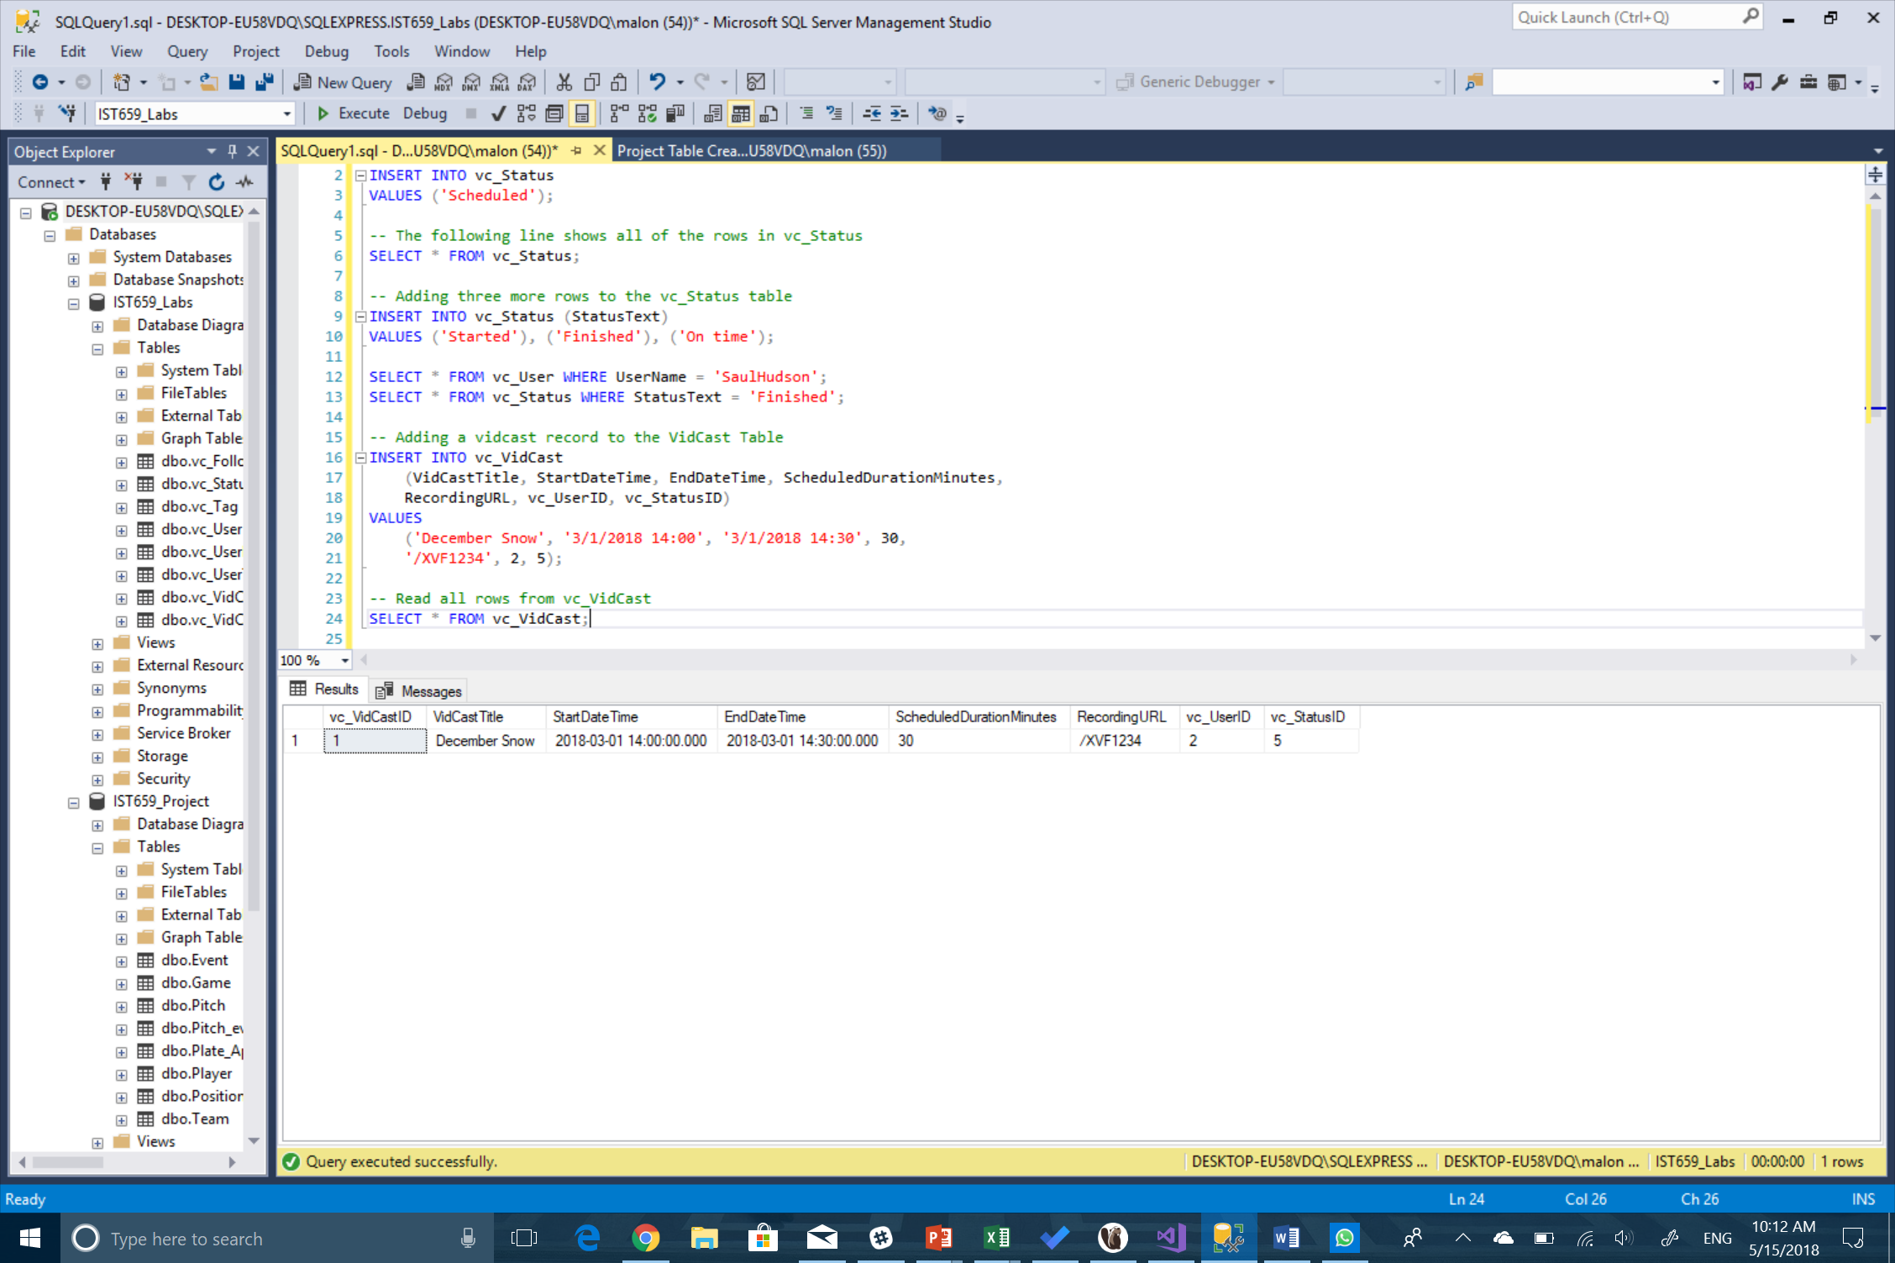

1. Saul’s First VidCast

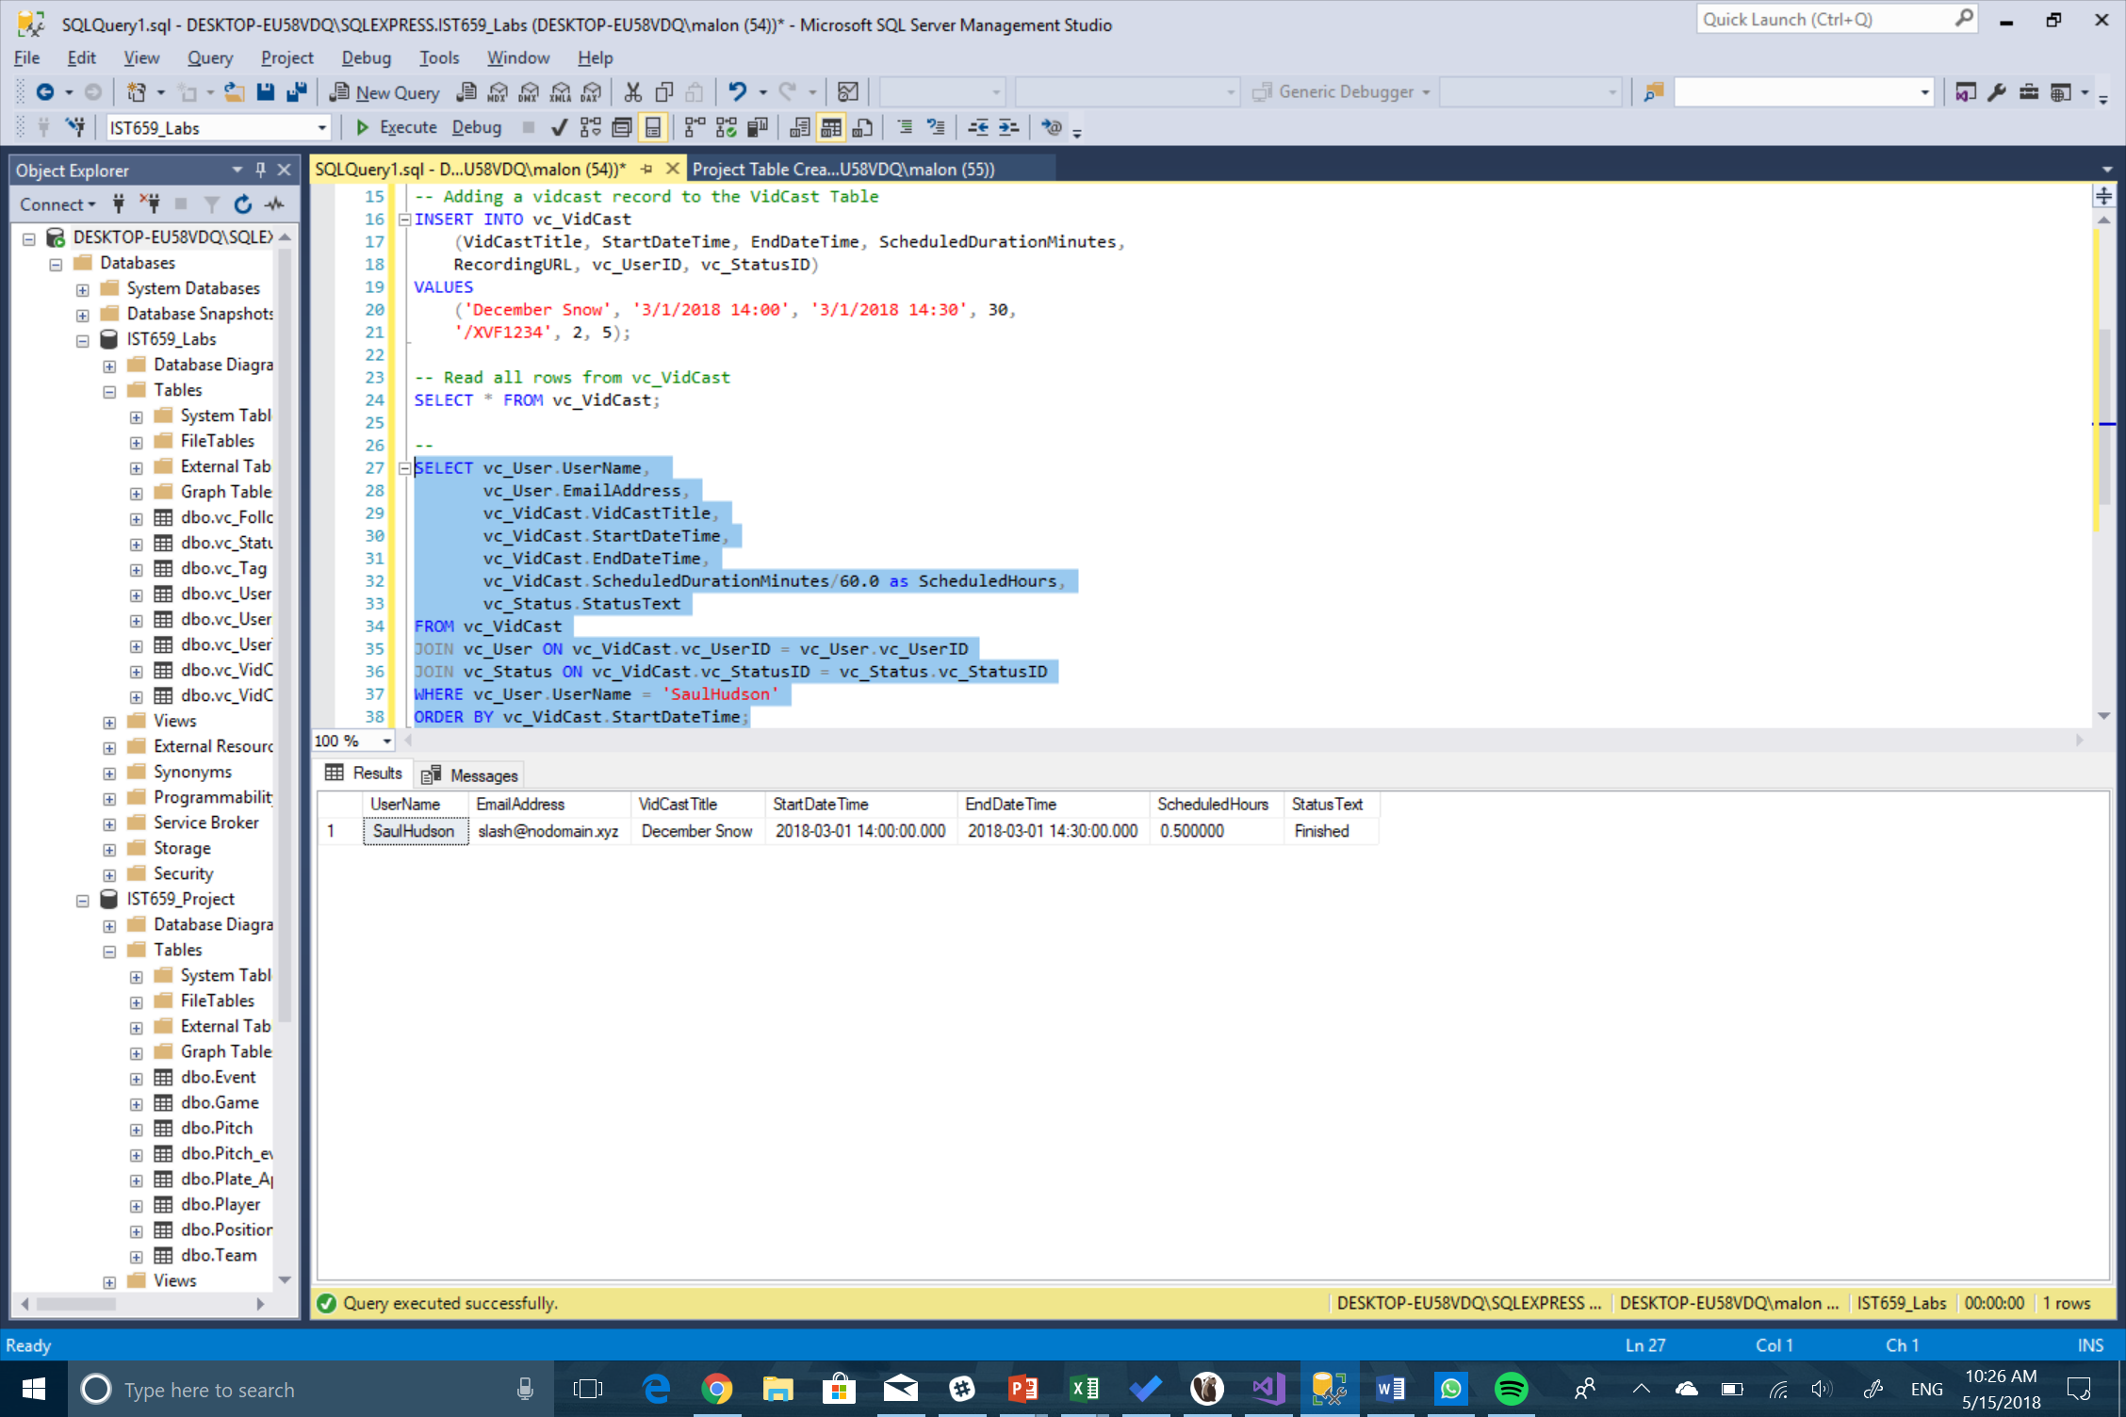

1. Update a User

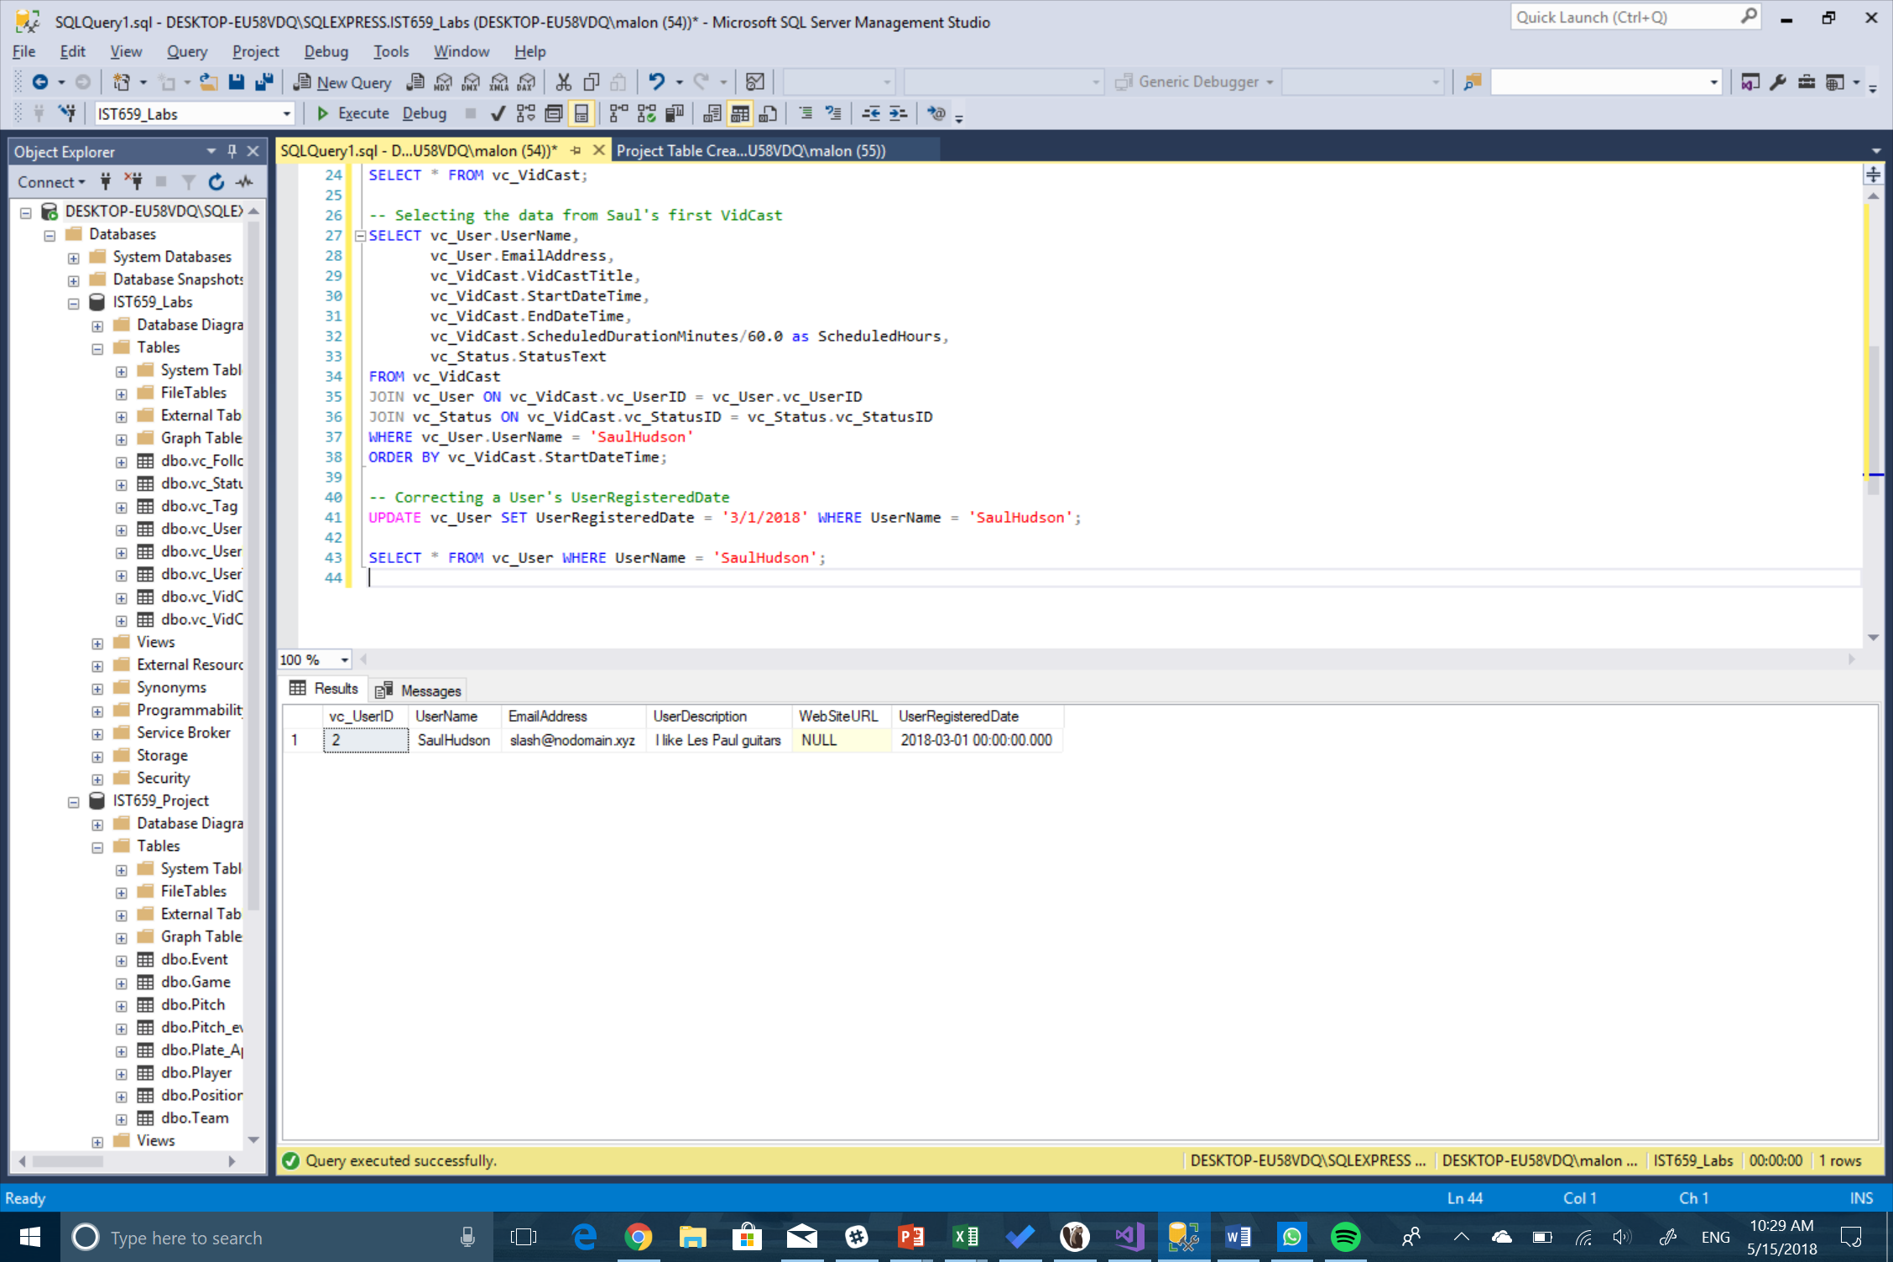

1. No more on time

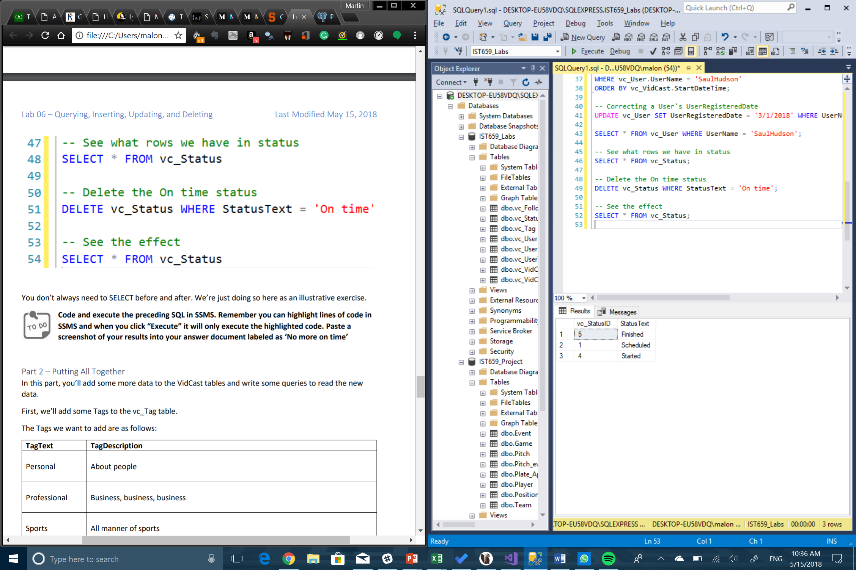

Part 2 – Putting it all together

1. Tags

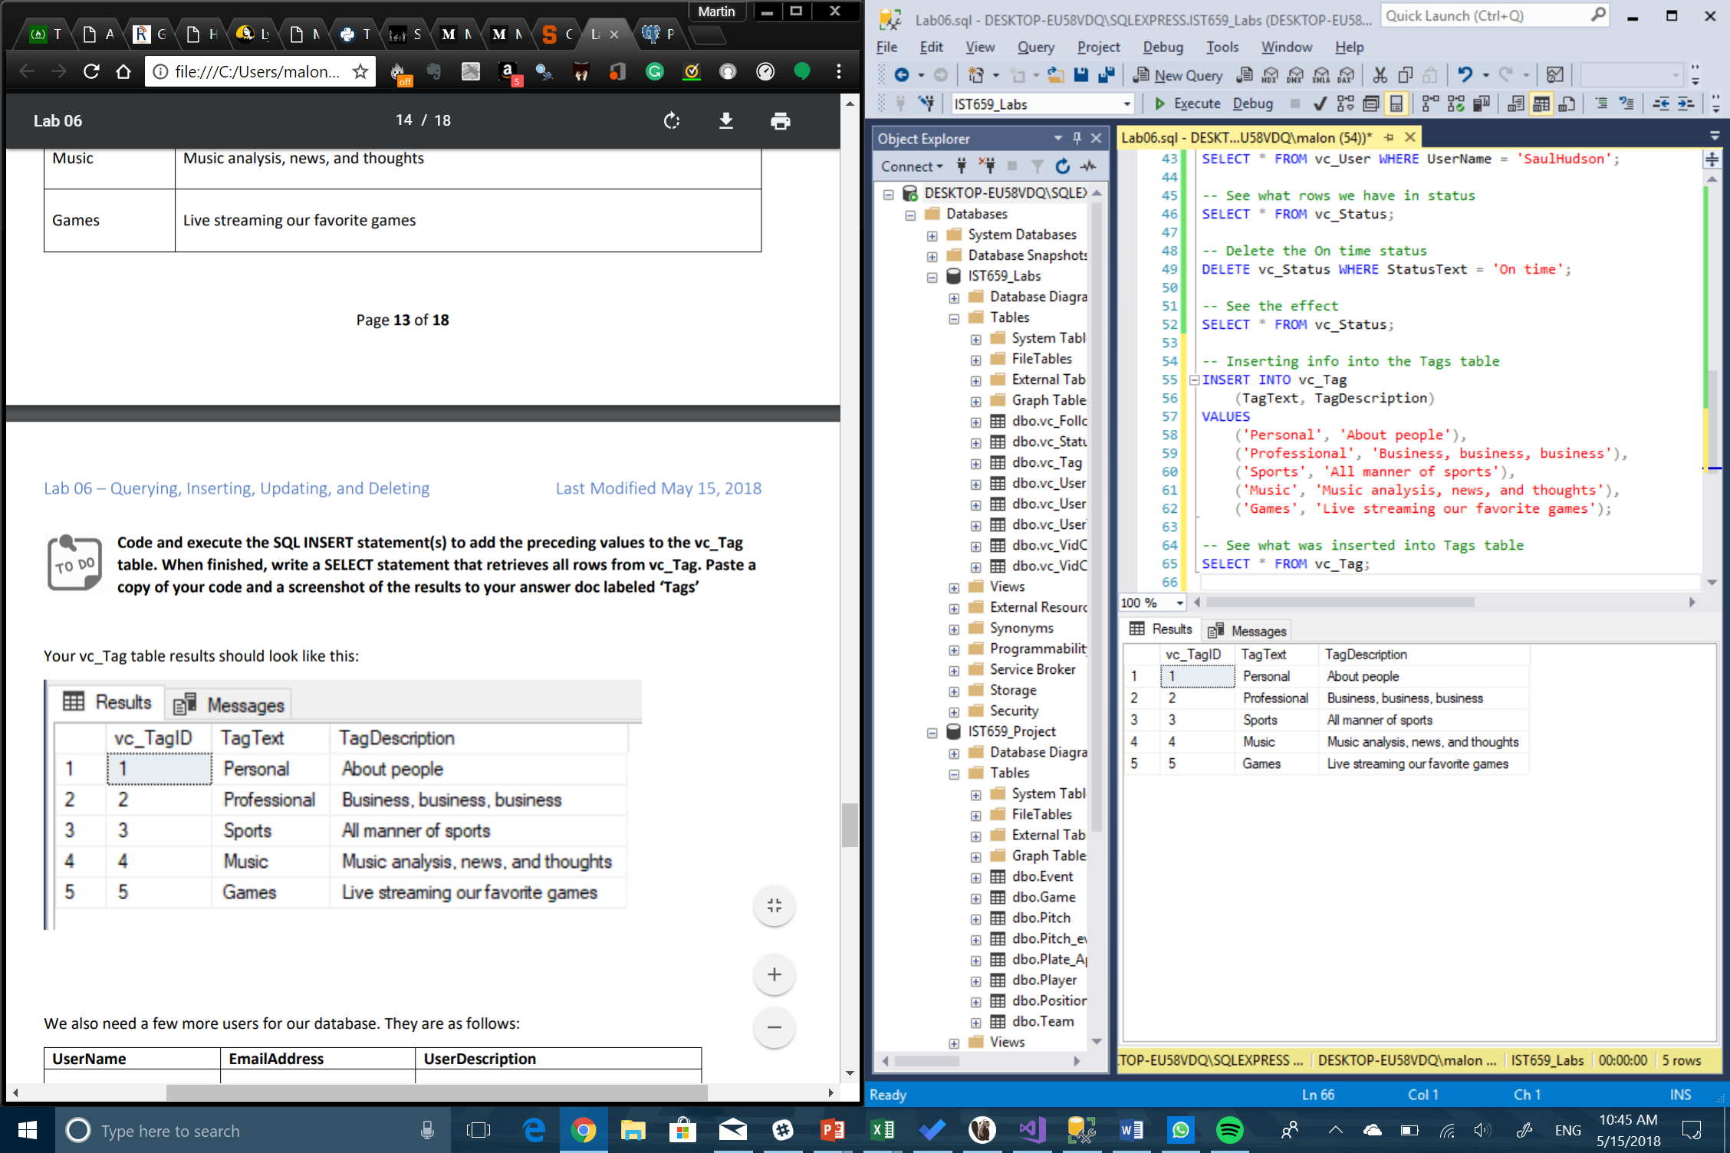

1. Users

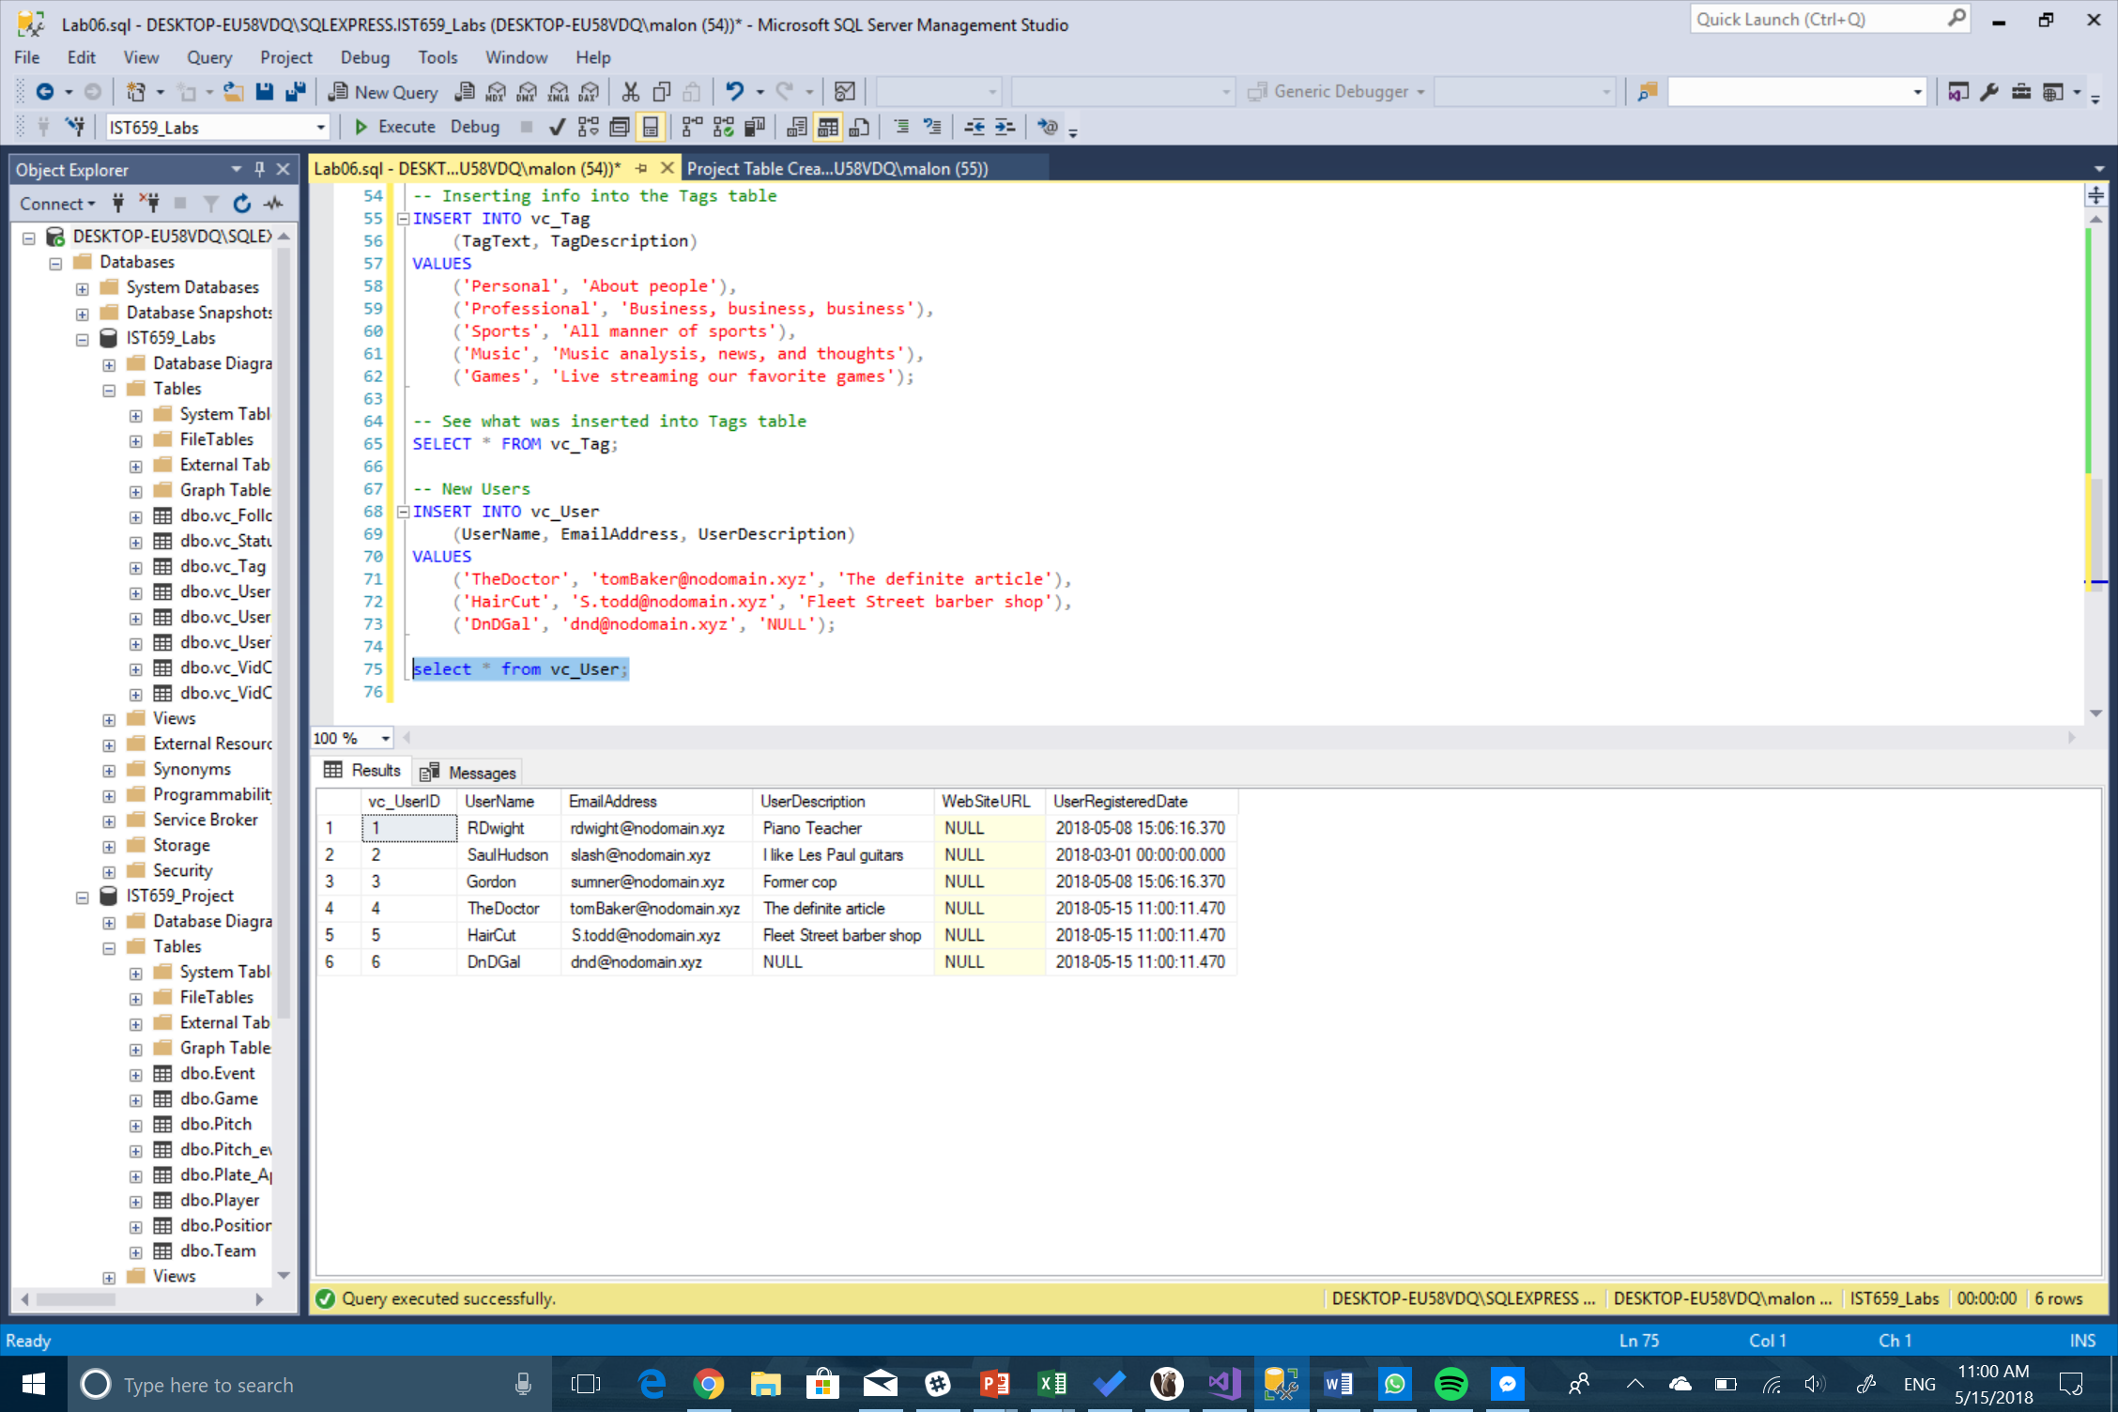

1. User Tag List

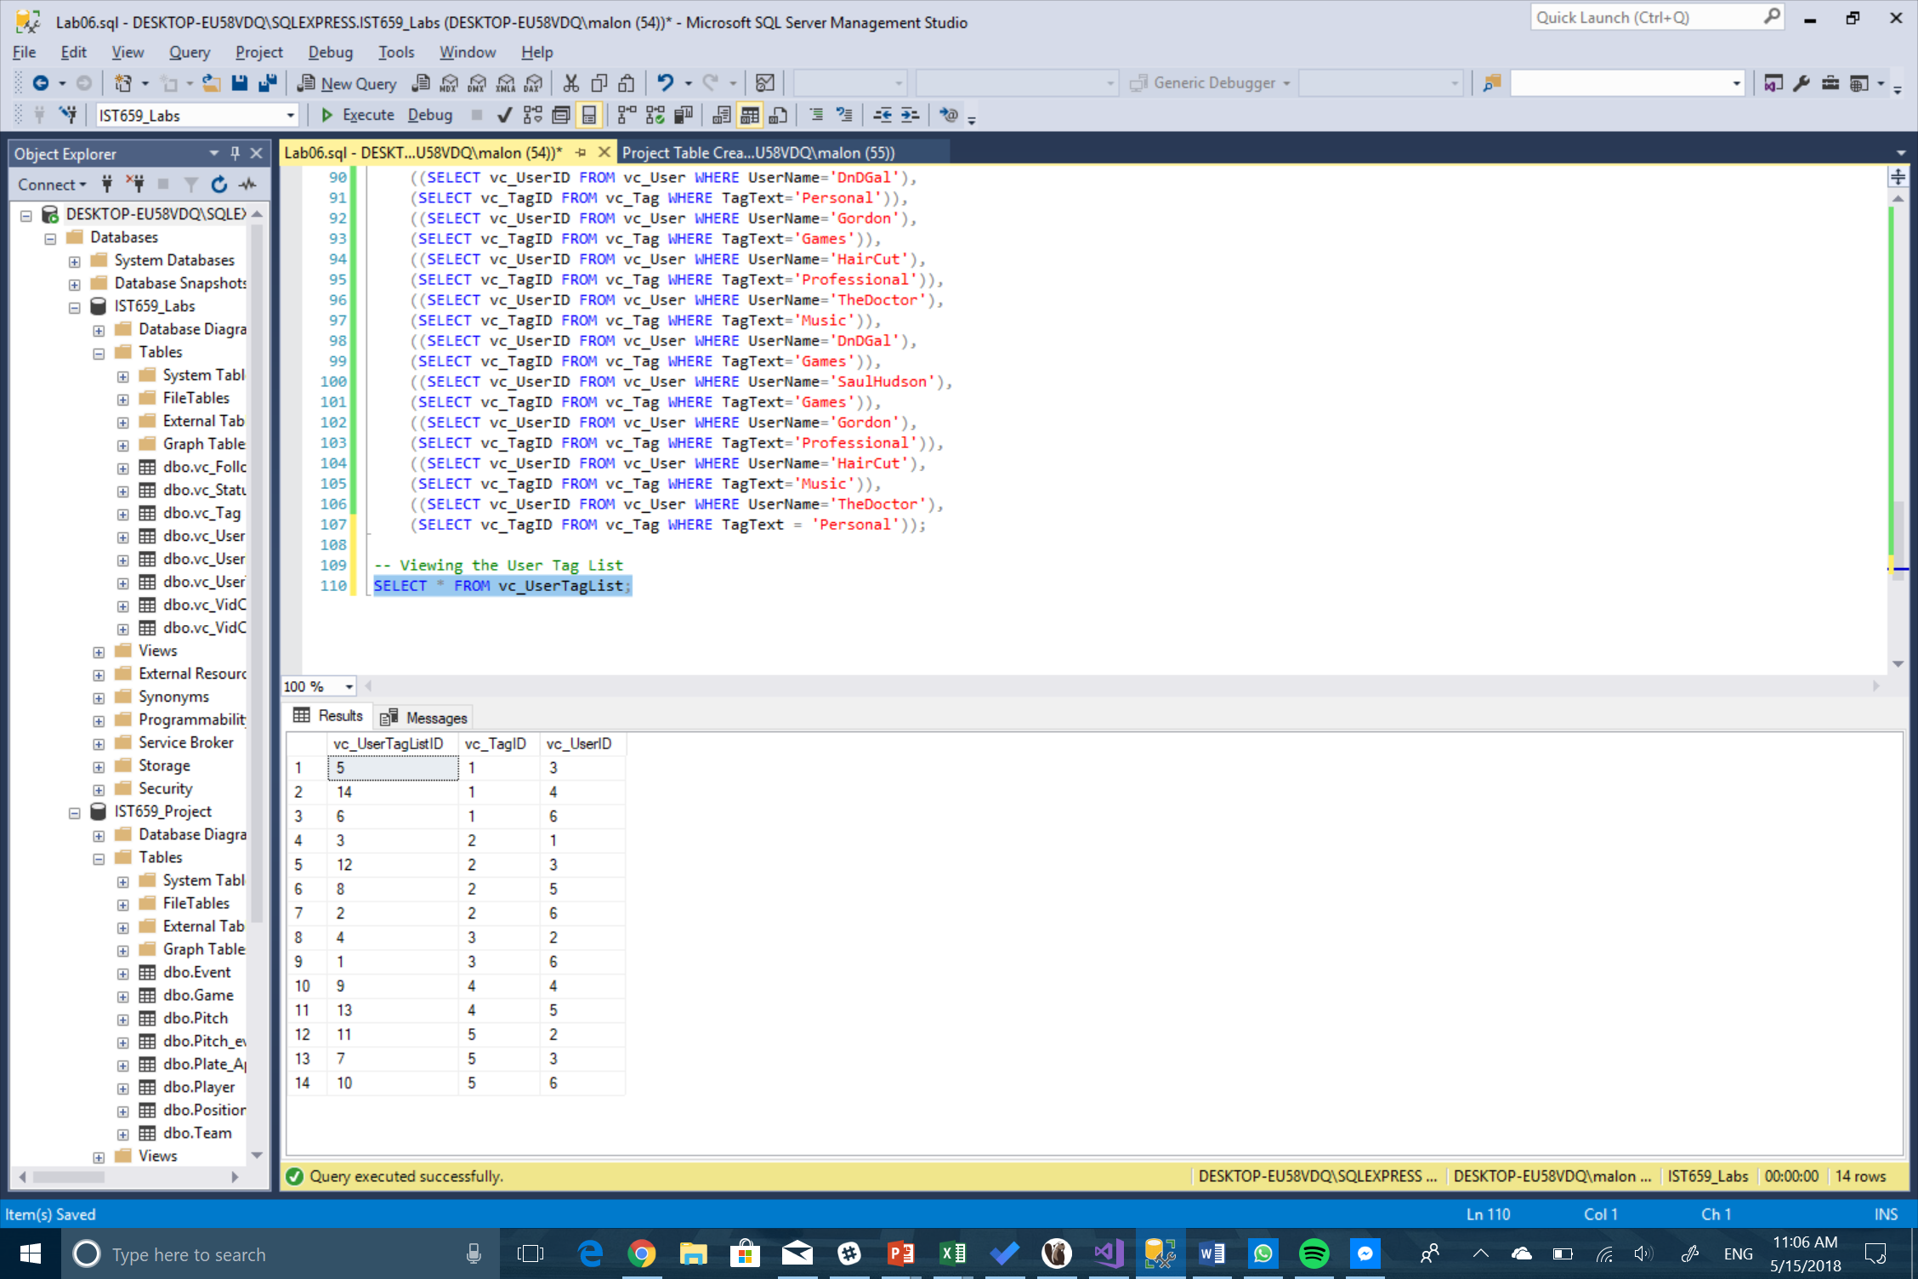

1. User Tag Report

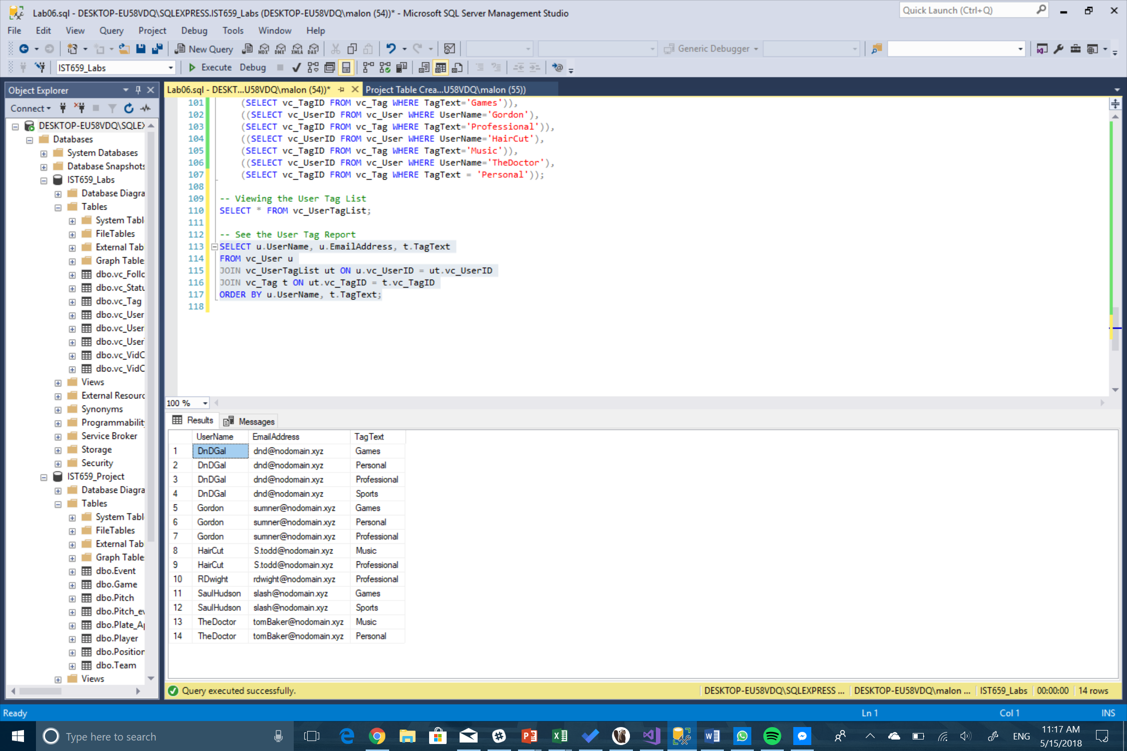

1. SQL Code
2. -- Adding a row to the vc_Status table
3. INSERT INTO vc_Status
4. VALUES ('Scheduled');
5. -- The following line shows all of the rows in vc_Status
6. SELECT * FROM vc_Status;
7. -- Adding three more rows to the vc_Status table
8. INSERT INTO vc_Status (StatusText)
9. VALUES ('Started'), ('Finished'), ('On time');
10. SELECT * FROM vc_User WHERE UserName = 'SaulHudson';
11. SELECT * FROM vc_Status WHERE StatusText = 'Finished';
12. -- Adding a vidcast record to the VidCast Table
13. INSERT INTO vc_VidCast
14. (VidCastTitle, StartDateTime, EndDateTime, ScheduledDurationMinutes,
15. RecordingURL, vc_UserID, vc_StatusID)
16. VALUES
17. ('December Snow', '3/1/2018 14:00', '3/1/2018 14:30', 30,
18. '/XVF1234', 2, 5);
19. -- Read all rows from vc_VidCast
20. SELECT * FROM vc_VidCast;
21. -- Selecting the data from Saul's first VidCast
22. SELECT vc_User.UserName,
23. vc_User.EmailAddress,
24. vc_VidCast.VidCastTitle,
25. vc_VidCast.StartDateTime,
26. vc_VidCast.EndDateTime,
27. vc_VidCast.ScheduledDurationMinutes/60.0 as ScheduledHours,
28. vc_Status.StatusText
29. FROM vc_VidCast
30. JOIN vc_User ON vc_VidCast.vc_UserID = vc_User.vc_UserID
31. JOIN vc_Status ON vc_VidCast.vc_StatusID = vc_Status.vc_StatusID
32. WHERE vc_User.UserName = 'SaulHudson'
33. ORDER BY vc_VidCast.StartDateTime;
35. -- Correcting a User's UserRegisteredDate
36. UPDATE vc_User SET UserRegisteredDate = '3/1/2018' WHERE UserName = 'SaulHudson';
37. SELECT * FROM vc_User WHERE UserName = 'SaulHudson';
38. -- See what rows we have in status
39. SELECT * FROM vc_Status;
40. -- Delete the On time status
41. DELETE vc_Status WHERE StatusText = 'On time';
42. -- See the effect
43. SELECT * FROM vc_Status;
44. -- Inserting info into the Tags table
45. INSERT INTO vc_Tag
46. (TagText, TagDescription)
47. VALUES
48. ('Personal', 'About people'),
49. ('Professional', 'Business, business, business'),
50. ('Sports', 'All manner of sports'),
51. ('Music', 'Music analysis, news, and thoughts'),
52. ('Games', 'Live streaming our favorite games');
53. -- See what was inserted into Tags table
54. SELECT * FROM vc_Tag;
55. -- New Users
56. INSERT INTO vc_User
57. (UserName, EmailAddress, UserDescription)
58. VALUES
59. ('TheDoctor', 'tomBaker@nodomain.xyz', 'The definite article'),
60. ('HairCut', 'S.todd@nodomain.xyz', 'Fleet Street barber shop'),
61. ('DnDGal', 'dnd@nodomain.xyz', 'NULL');
63. SELECT * FROM vc_User;
64. -- Inserting User Tag List info
65. INSERT INTO vc_UserTagList (vc_UserID, vc_TagID)
66. VALUES
67. ((SELECT vc_UserID FROM vc_User WHERE UserName='DnDGal'),
68. (SELECT vc_TagID FROM vc_Tag WHERE TagText='Sports')),
69. ((SELECT vc_UserID FROM vc_User WHERE UserName='DnDGal'),
70. (SELECT vc_TagID FROM vc_Tag WHERE TagText='Professional')),
71. ((SELECT vc_UserID FROM vc_User WHERE UserName='RDwight'),
72. (SELECT vc_TagID FROM vc_Tag WHERE TagText='Professional')),
73. ((SELECT vc_UserID FROM vc_User WHERE UserName='SaulHudson'),
74. (SELECT vc_TagID FROM vc_Tag WHERE TagText='Sports')),
75. ((SELECT vc_UserID FROM vc_User WHERE UserName='Gordon'),
76. (SELECT vc_TagID FROM vc_Tag WHERE TagText='Personal')),
77. ((SELECT vc_UserID FROM vc_User WHERE UserName='DnDGal'),
78. (SELECT vc_TagID FROM vc_Tag WHERE TagText='Personal')),
79. ((SELECT vc_UserID FROM vc_User WHERE UserName='Gordon'),
80. (SELECT vc_TagID FROM vc_Tag WHERE TagText='Games')),
81. ((SELECT vc_UserID FROM vc_User WHERE UserName='HairCut'),
82. (SELECT vc_TagID FROM vc_Tag WHERE TagText='Professional')),
83. ((SELECT vc_UserID FROM vc_User WHERE UserName='TheDoctor'),
84. (SELECT vc_TagID FROM vc_Tag WHERE TagText='Music')),
85. ((SELECT vc_UserID FROM vc_User WHERE UserName='DnDGal'),
86. (SELECT vc_TagID FROM vc_Tag WHERE TagText='Games')),
87. ((SELECT vc_UserID FROM vc_User WHERE UserName='SaulHudson'),
88. (SELECT vc_TagID FROM vc_Tag WHERE TagText='Games')),
89. ((SELECT vc_UserID FROM vc_User WHERE UserName='Gordon'),
90. (SELECT vc_TagID FROM vc_Tag WHERE TagText='Professional')),
91. ((SELECT vc_UserID FROM vc_User WHERE UserName='HairCut'),
92. (SELECT vc_TagID FROM vc_Tag WHERE TagText='Music')),
93. ((SELECT vc_UserID FROM vc_User WHERE UserName='TheDoctor'),
94. (SELECT vc_TagID FROM vc_Tag WHERE TagText = 'Personal'));
95. -- Viewing the User Tag List
96. SELECT * FROM vc_UserTagList;
97. -- See the User Tag Report
98. SELECT u.UserName, u.EmailAddress, t.TagText
99. FROM vc_User u
100. JOIN vc_UserTagList ut ON u.vc_UserID = ut.vc_UserID
101. JOIN vc_Tag t ON ut.vc_TagID = t.vc_TagID
102. ORDER BY u.UserName, t.TagText;